- A big upside surprise for UK GDP in December added to our concerns that the data is suffering from residual seasonality. We think the strength of H1 2024 and the scale of the H2 slowdown are exaggerated. The strong launchpad provided by December's data means there's a good chance the Q1 2025 outturn will be strong, but we still think calendar year growth will be around 1%.
- Megan Greene and Huw Pill both argued that weak growth in supply justified the Monetary Policy Committee's more hawkish tone. But with both members having previously leaned towards the more hawkish end of the MPC spectrum, it's hard to gauge how widespread the concerns about supply have become.
Frustration with the quality of official statistics has been a regular theme of our commentary in recent years. This has mostly centred on the beleaguered Labour Force Survey. But data quality concerns are increasingly broadening out into other releases, with major questions emerging about the GDP data.
December saw a major upside surprise for GDP, with broad-based strength underpinning a 0.4% m/m rise. Coming on the back of a modest increase in November, this meant the economy eked out GDP growth of 0.1% in Q4 2024 as a whole.
But looking at how the latest data sits in a wider context has deepened our concerns about residual seasonality. Over the past three years, the GDP data has shown much stronger momentum in H1 of each year, with growth slowing abruptly in Q3 (Chart 1). Today's data increases the chances this pattern will continue in 2025 – even if GDP was flat until March, growth in Q1 as a whole would still be 0.3% because of the high starting point offered by the December outturn.
Though it increasingly looks like the extent of the H2 2024 slowdown was exaggerated by residual seasonality, the expenditure breakdown for Q4 looked less favourable than prior quarters. Consumer spending was flat, while business investment fell, leaving growth reliant on government spending and stockbuilding.
Chart 1: The ONS's problem with residual seasonality is becoming increasingly clear
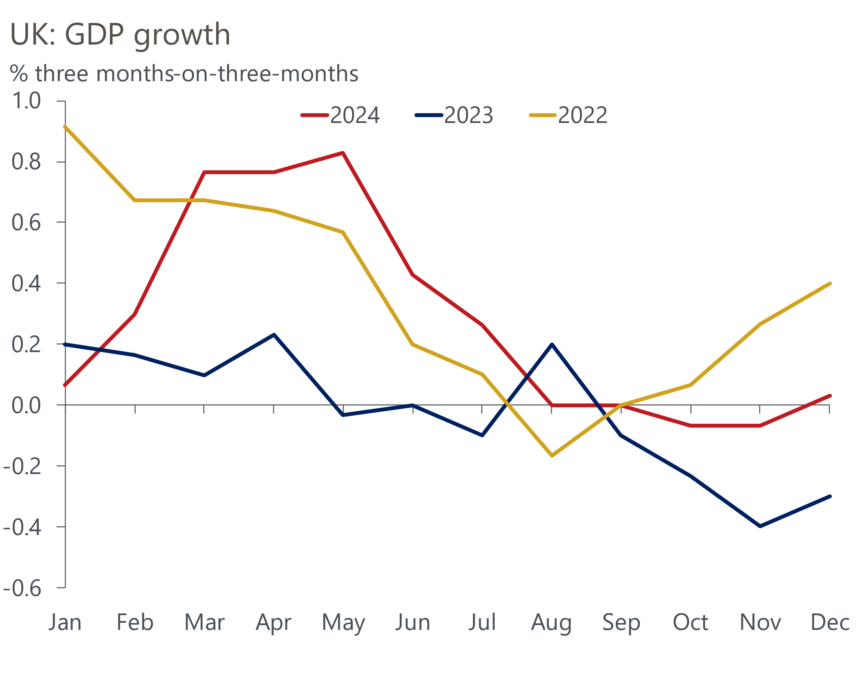
Source: Haver Analytics

For the time being, we will trust that the Office for National Statistics will get on top of the residual seasonality problem, rather than build in a seasonal pattern as a permanent feature of our GDP forecast. Next week's UK Country Economic Forecast will incorporate the new GDP data and it's likely that our forecast for 2025 GDP growth will remain close to 1%.
The Office for Budget Responsibility's 2025 forecast is currently 2%, but we expect the official forecaster to drop back close to our projection when it publishes its next update on March 26. Past experience suggests the OBR is likely to have locked its financial market assumptions this week, and we calculate that higher gilt yields and market expectations for Bank Rate are likely to have knocked around £6bn off the £9.9bn of headroom left at the Budget (Chart 2).
Chart 2: Higher gilt yields and Bank Rate expectations could wipe £6bn off the Chancellor's headroom
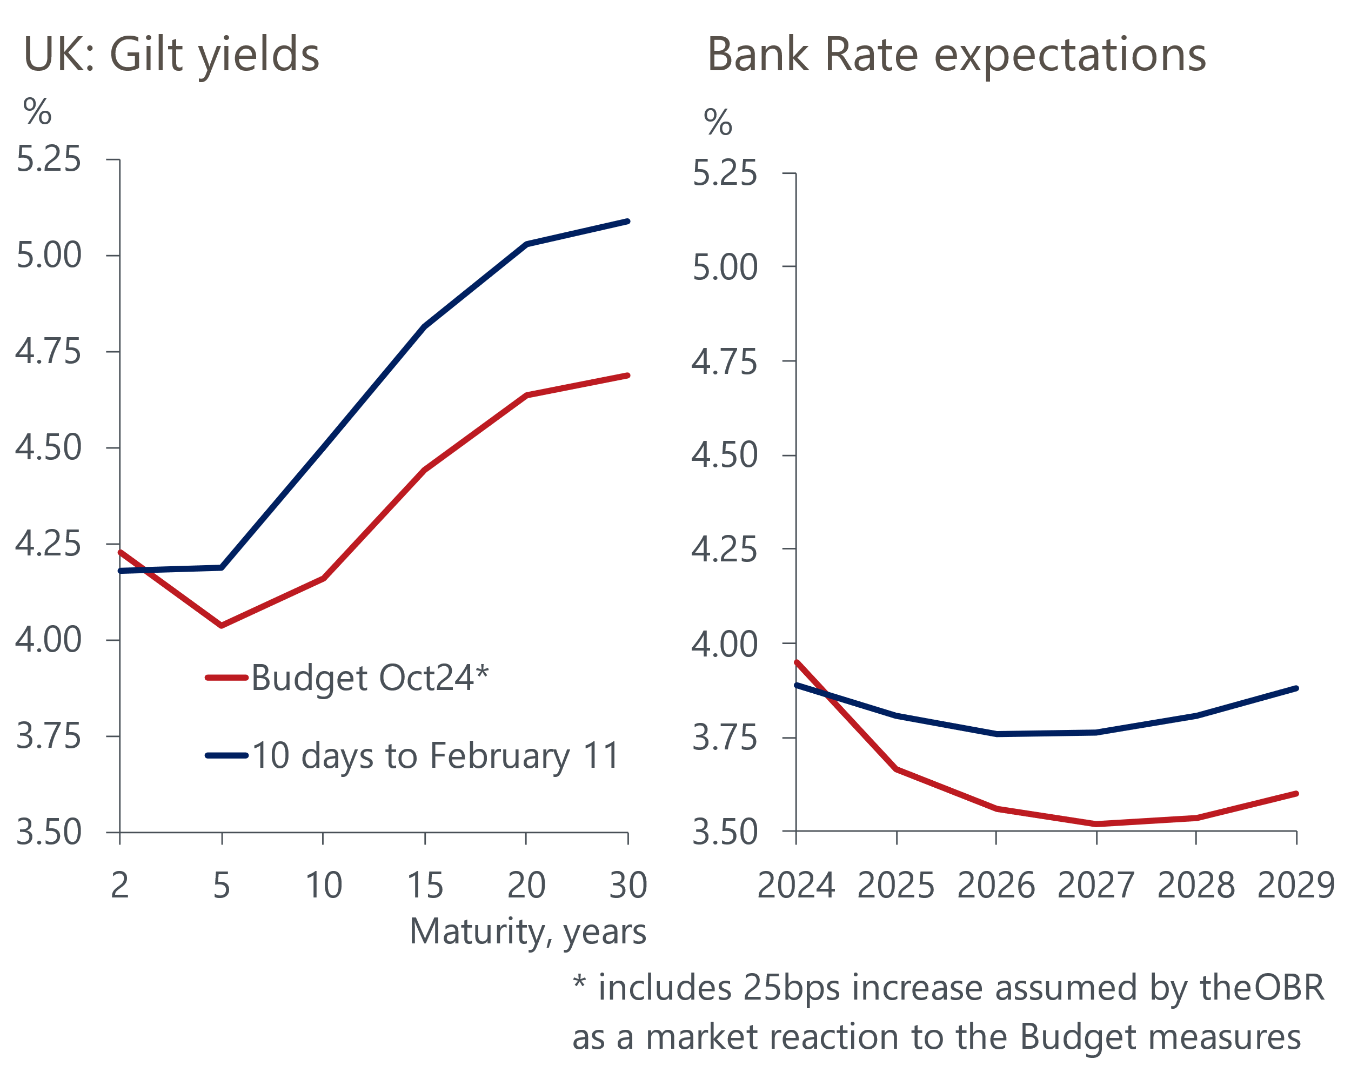
Source: Haver Analytics
Whether the remaining headroom remains intact will depend on the OBR's judgements on other factors where the process is less transparent. Their projections for potential output growth (too strong) and pay growth (too weak) look particularly ripe for revision. But these changes would have opposing impacts on the public finances. Beyond March's update, the economy's response to much tighter fiscal policy will be key. Our latest note finds that history suggests the risk of failure is high. Only half of fiscal adjustments succeed, with revenue-based consolidations typically being less successful than spending-based ones.
Turning to monetary policy, three Monetary Policy Committee members have offered their takes on last week's meeting. Catherine Mann gave a speech and Financial Times interview to explain her sudden switch from being the most hawkish member to the most dovish. Mann has always been a fringe voice on the committee and there's no evidence to suggest her latest take has broader support.
Megan Greene and Huw Pill also tended to lean towards the more hawkish end of the spectrum last year but they've been more reliable bellwethers of MPC sentiment than Mann. Greene offered a much clearer explanation of the reasoning behind last week's hawkish message than the Bank of England managed at the time. She said the MPC's mid-range inflation scenario remained most likely to play out, but thought the risks had shifted away from the benign scenario towards the one where inflation proves more persistent.
That the MPC had become bogged down in a bizarre debate about whether they should be "cautious and gradual" or "gradual and careful" was one of the reasons last week's comms were difficult to parse. And Pill's interview with Reuters briefly disappeared down the same rabbit hole. But Pill agreed with Greene that while rates are likely to be cut further, concerns about weak supply suggest the MPC should move slowly.
Wage growth – both the strength of recent data and firmer-than-expected results from the BoE's pay survey – seems to be behind renewed hawkishness. For now, we stick with our call that the MPC will continue to cut at every other meeting. But if the more centrist or dovish members were to express similarly strong reservations over supply, it would tip the balance of risks towards fewer rate cuts this year.

The week ahead
Results from the Labour Force Survey remain very volatile, as the Office for National Statistics continues to battle with low survey response rates. Last month's release saw a spike in the single-month unemployment rate drive up the three-month average that the ONS reports as its headline rate. We expect the three-month average to hold steady at that higher level of 4.4% in October to December.
A combination of renewed momentum and favourable base effects have pushed up pay growth in recent months. These factors are likely to remain influential in December's data, and we expect headline total and regular pay growth to accelerate to 5.9%, from 5.6% in the three months to November.
Inflation surprised on the downside in December because of timing effects in the volatile air fares and accommodation and food categories. We expect both effects to unwind in January's data, while the imposition of VAT on private school fees will also push up services inflation. But the upward pressure will be mitigated by a slightly larger drag from energy, with the increase in the energy price cap this January having been slightly smaller than last year's rise. We expect CPI inflation to come in at 2.9% in January.
Retail sales fell modestly in December, following a sharp drop in sales in food stores. This was a repeat of what happened in December 2023 and that was followed by a strong rebound in sales in food stores in January 2024. With the same seasonal pattern looking likely to play out this year, we expect retail sales to have risen 0.6% m/m in January.
Table 1: Week ahead calendar
Date | Events | Period | Measure | Unit | Previous | Forecast
Feb 18 | LFS unemployment | Oct-Dec | Rate | % | 4.4 | 4.4
Feb 18 | Average earnings (total pay) | Dec | 3m, y/y | % | 5.6 | 5.9
Feb 18 | Average earnings (regular pay) | Dec | 3m, y/y | % | 5.6 | 5.9
Feb 19 | CPI inflation | Jan | m/m | % | 0.3 | -0.2
Feb 19 | CPI inflation | Jan | y/y | % | 2.5 | 2.9
Feb 19 | RPI inflation | Jan | m/m | % | 0.3 | 0.1
Feb 19 | RPI inflation | Jan | y/y | % | 3.5 | 3.9
Feb 19 | Producer input prices | Jan | m/m | % | 0.1 | 0.2
Feb 19 | Producer input prices | Jan | y/y | % | -1.5 | -1.0
Feb 19 | Producer output prices | Jan | m/m | % | 0.1 | 0.1
Feb 19 | Producer output prices | Jan | y/y | % | 0.1 | 0.0
Feb 19 | Land Registry house prices | Nov | y/y | % | 3.3 | 3.9
Feb 21 | GfK consumer confidence | Feb | Headline | % bal | -22 | -22
Feb 21 | Retail sales inc fuel | Jan | m/m | % | -0.3 | 0.6
Feb 21 | Retail sales inc fuel | Jan | y/y | % | 3.6 | 0.5
Feb 21 | Public finances | Jan | PSNB ex | £bn | 17.8 | -17.0
Feb 21 | S&P Global manufacturing | Feb | PMI | % bal | 48.3 | 48.5
Feb 21 | S&P Global services | Feb | PMI | % bal | 50.8 | 51.0
Feb 21 | S&P Global composite | Feb | PMI | % bal | 50.6 | 50.8
Source: Oxford Economics

Key forecasts
Table 2: UK forecast overview
(Annual percentage changes unless specified)
 | 2022 | 2023 | 2024 | 2025 | 2026 | 2027
GDP | 4.8 | 0.4 | 0.8 | 1.0 | 1.6 | 1.7
Private consumption | 7.3 | 0.4 | 1.0 | 1.3 | 1.4 | 1.5
Fixed investment | 5.1 | 0.3 | 1.1 | 0.2 | 3.2 | 2.5
Government consumption | 0.6 | 1.0 | 2.1 | 2.6 | 1.6 | 1.6
Exports of goods and services | 12.6 | -3.2 | -2.5 | -0.8 | 1.2 | 1.5
Imports of goods and services | 13.0 | -4.5 | 1.6 | 0.4 | 1.6 | 1.3
Industrial Production | -6.4 | -0.9 | -1.6 | -0.4 | 1.1 | 1.2
Consumer prices | 9.1 | 7.3 | 2.5 | 3.1 | 2.5 | 2.1
Unemployment rate (%) | 3.8 | 4.1 | 4.3 | 4.5 | 4.5 | 4.3
Current a/c balance (% of GDP) | -2.2 | -2.2 | -2.8 | -3.0 | -2.9 | -2.7
Government balance (% of GDP) | 4.1 | 5.2 | 4.9 | 3.2 | 2.8 | 2.2
Central bank policy rate (%, EOP) | 3.50 | 5.25 | 4.75 | 3.75 | 3.00 | 2.50
10yr govt. bond yield (%, EOP) | 3.67 | 3.54 | 4.57 | 4.41 | 3.91 | 3.45
Exchange rate (US$ per £, EOP) | 1.20 | 1.27 | 1.25 | 1.22 | 1.24 | 1.25
Exchange rate (euro per £, EOP) | 1.13 | 1.15 | 1.21 | 1.21 | 1.21 | 1.21
Source: Oxford Economics
Table 3: Quarterly forecasts for the UK
 | 2024 |  |  |  | 2025
 | Q1 | Q2 | Q3 | Q4 | Q1 | Q2 | Q3 | Q4
GDP (% year) | 0.3 | 0.7 | 0.9 | 1.1 | 0.8 | 0.8 | 1.1 | 1.5
CPI inflation (% year) | 3.5 | 2.1 | 2.1 | 2.5 | 2.7 | 3.0 | 3.5 | 3.4
Bank Rate (%, EOP) | 5.25 | 5.25 | 5.00 | 4.75 | 4.50 | 4.25 | 4.00 | 3.75
10yr gilt yield (%, EOP) | 3.95 | 4.17 | 4.00 | 4.57 | 4.57 | 4.57 | 4.50 | 4.41
US$ per £ (EOP) | 1.26 | 1.26 | 1.34 | 1.25 | 1.24 | 1.22 | 1.22 | 1.22
Euro per £ (EOP) | 1.17 | 1.18 | 1.20 | 1.21 | 1.20 | 1.21 | 1.21 | 1.21
Source: Oxford Economics

Latest Country Economic Forecast:
January 22, 2025

Recent publications

Data Insights
A better December for GDP but H2 2024 still looks very soft
PMIs suggest growth off to a slow start in 2025
January's manufacturing PMI pointed to softer decline in activity
Mortgage approvals picked up a little at the end of 2024
The PMIs started 2025 on a slightly brighter note

Research Briefings
The UK's fiscal adjustment is at risk of failure
MPC cuts rates, but growth-inflation dynamic is worsening
MPC preview – Maintaining the dovish message
A plan for growth - next steps
Labour market data woes show the importance of nowcasts

Contacts

Oxford Economics' UK team
- Andrew Goodwin - Chief UK Economist - agoodwin@oxfordeconomics.com
- Edward Allenby - UK Economist - eallenby@oxfordeconomics.com

